Appendix E-2

Deliverability Evaluation Process Description
For
2006
Request For Proposals (RFP)
For
Long-Term
Supply-Side Resources

Entergy Services, Inc.
April 17, 2006
1.0 Introduction

This Appendix E-2 describes the methodology the RFP evaluation’s Transmission Analysis Group (“TAG”) will use during the Economic Evaluation Team’s (“EET”) Stage 1 analysis (described in Appendix E-1) to identify and analyze deliverability issues presented by resources that are the subject of proposals submitted in response to the 2006 Long-Term RFP. The interactions of the Stage 1 analyses conducted by the EET and the TAG are shown in Chart A below. During the Stage 2 evaluation process, the TAG may provide technical support as requested.

As discussed in greater detail below, proposals submitted in response to this RFP ultimately are expected to qualify as Long-Term Network Resources under Network Integration Transmission Service as described on the Entergy OASIS website. However, Bidders are not expected to estimate and include in their proposals the cost necessary for a resource to become a Long-Term Network Resource. Instead, except as otherwise stated in Section 1.1, Buyer will assume the responsibility for requesting and obtaining, including the costs associated therewith, qualification of a proposed resource as a Long-Term Network Resource for the Entergy System.

During the EET’s Stage 1 Evaluation, TAG will evaluate transmission deliverability issues in two phases: an initial transmission analysis (conducted on all conforming proposals) and a detailed transmission evaluation (conducted on “Candidate Proposals”, a set of proposals from which the Preliminary Shortlist is drawn). The initial transmission analysis, which consists of several parts described in detail later, will be performed on every resource that is the subject of a conforming proposal submitted in response to this RFP. The results of the TAG’s initial transmission analysis will be provided to the EET to assist in creating the Candidate Proposal list. The detailed transmission evaluation will be performed on the Candidate Proposals to determine the appropriate mitigation alternatives for the constrained resources. Utilizing the results of that evaluation, and in the event the results of the System Impact Study (“SIS”) are received timely (considered to be within ninety (90) days from initial submission through the Entergy OASIS website), the TAG will develop (as discussed more fully below) a cost estimate for obtaining the appropriate transmission service for the resource (“Delivery Cost Adders”) to be considered in the economic evaluation. This methodology is described in more detail in section 2.0 below.

It should be noted that Entergy’s Transmission Business Unit (“TBU”) has proposed certain changes to its Open Access Transmission Tariff (“OATT”), whereby TBU will contract with an independent entity, the Independent Coordinator of Transmission (“ICT”) to oversee the administration of Entergy’s OATT and undertake certain functions under that tariff. Among other responsibilities, the proposed ICT will develop a Base Plan to determine which transmission upgrades are required for reliability and which are Supplemental Upgrades for purposes of cost allocation. Under the ICT Proposal’s new pricing policy for transmission upgrades, Base Plan Upgrades would be eligible for recovery in transmission rates while Supplemental Upgrades would be paid by the requesting party. The Weekly Procurement Process in the ICT Proposal is a process intended to integrate the procurement of power with the granting of transmission service.

The ICT Proposal, including the associated pricing policy and Weekly Procurement Process, is under review by the FERC and certain state regulatory agencies. Depending upon the outcome of these reviews, changes to this evaluation methodology may become necessary. In addition, any other opportunities which improve the ability of the Entergy Operating Companies to further integrate generation and transmission information in their resource procurement efforts to the extent permitted by FERC Standards of Conduct, also will be taken into consideration.

To the extent that information is obtained concerning the ICT Proposal, the Weekly Procurement Process, or other evaluations within a time frame that can be incorporated into the evaluation process, changes to this evaluation process may be implemented. Any material changes to this RFP evaluation that ESI deems necessary in light of these events will be discussed with the IMs and the staffs of regulatory commission(s) participating in this 2006 Long-Term RFP process prior to implementation, and the appropriate notification will be posted to the RFP website.

1.1 Generating Units Outside the Entergy Control Area

For resources located outside the Entergy Control Area proposed as a PPA, the Bidder/Seller shall be required to obtain firm point-to-point transmission service to the Entergy Control Area for the entire Delivery Term. For resources located outside the Entergy Control Area proposed as an acquisition, the Bidder/Seller is required to provide cost estimates associated with delivery of the resource to the Entergy Control Area through firm point-to-point transmission service for the design life of the resource. This estimate should include the costs of any transmission upgrades, as well as the tariff rates that will be charged to deliver energy from the proposed resource to the Entergy Control Area. With the exception of transmission service credits arising from interconnection-related costs, which are discussed in Sections 1.2 and 1.3 of this Appendix, the Bidder/Seller may propose to transfer existing transmission rights or other transmission arrangements to the Buyer.

1.2 Transmission Interconnection Requirements
For generating resources interconnecting with the Entergy System, the Bidder/Seller is responsible for complying with Entergy’s OATT administered pursuant to FERC Order No. 2003-A’s Standard Large Generator Interconnection Agreement and Standard Large Generator Interconnection Procedures or any successor requirements in effect. Under an acquisition, the Bidder/Seller will not be responsible for complying with changes or modifications to Entergy’s OATT administered pursuant to FERC Order No. 2003-A’s Standard Large Generator Interconnection Agreement and Standard Large Generator Interconnection Procedures or any successor requirements after the closing of the acquisition. Bidder/Seller assumes all risks with regard to transmission interconnection with the Entergy Control Area including, but not limited to, the cost of interconnection, the treatment of any associated transmission service credits, and any charges associated with reliability requirements.

In the event that the proposed resource does not have a signed Interconnection Agreement or has not already submitted a request to perform an interconnection study with TBU, the Bidder/Seller must initiate this process and submit the appropriate information to the TBU prior to submitting its proposal. Failure to submit the appropriate information to the TBU will cause a proposal to be considered non-conforming. It is not necessary for the Bidder to have received the results of the interconnection study or to have entered into a signed Interconnection Agreement in order to submit a proposal; rather, the interconnection process must have been initiated with TBU, including the submission of the information required by TBU.

1.3 Transmission Credits

The Bidder/Seller assumes all risks with regard to transmission interconnection with the Entergy transmission system (and in the case of resources located outside the Entergy Control Area, interconnection with any other transmission system) including, but not limited to, the cost of interconnection, the treatment of any associated transmission service credits, and any charges associated with reliability requirements. Any transmission service credits existing or forthcoming associated with upgrades constructed as a result of the interconnection studies discussed above will be retained by the Bidder/Seller and will be subject to the applicable contemporaneous rules in effect. Therefore, Bidders/Sellers are encouraged to exclude from their proposal, but are not prohibited from including, the interconnection costs that qualify for transmission service credit.

It should be noted that the extent to which interconnection-related costs give rise to transmission service credits under the Entergy OATT will be a function of the OATT provisions that are applicable at the time of the service. To the extent a Bidder’s interconnection-related costs for a generation resource are determined to be credit-eligible under the applicable OATT rules, if the Bidder’s generation resource is selected under this RFP and becomes a Long-Term Network Resource of the Entergy System, TBU will render the financial compensation for the credits to the Bidder/Seller. Therefore, it is not necessary for the Bidder to proffer such prospective credits to Buyer as part of its proposal in order for the credits to have value to the Bidder. In fact, ESI discourages Bidders from proffering such credits. ESI’s preference is for the Bidder to retain such credits. The Bidder may make its own judgment about the prospective value of any such credits. The same principles regarding transmission service credits arising from interconnection-related costs apply for resources located outside the Entergy Control Area.

To the extent a Bidder has funded upgrades on another transmission system, and has transmission credits associated with those upgrades, ESI also discourages Bidders from proffering such credits. ESI’s preference is for the Bidder to retain such credits. However, to the extent that a Bidder wants to be compensated by ESI for those credits, ESI would be willing to transfer any financial compensation associated with such credits to the Seller contemporaneously with the Buyer’s receipt of such compensation from the transmission owner.

2.0 The Transmission Evaluation Methodology

This section describes the analysis that the TAG will conduct in connection with this RFP. That analysis will develop estimates of the potential transmission benefits associated with conforming proposals and the potential transmission costs associated with Candidate Proposals. The potential transmission benefits that will be estimated include savings derived from relieving reliability must run constraints, providing counter-flow on constrained transmission elements, and delaying budgeted transmission improvements. The potential transmission costs that will be estimated include the costs associated with qualifying a proposal as a Long-Term Network Resource. The estimated potential transmission benefits and costs will be used by the EET in the Stage 1 analysis during development of the Candidate Proposal list.

For all of the analyses conducted under this methodology, the TAG will use loadflow models that are posted on the Entergy OASIS website for the steady state analysis (thermal and voltage) used in this methodology. The TAG also will provide on the RFP Website a description of how the posted information will be used. The TAG will utilize PTI’s MUST software for this analysis, which is proprietary and must be purchased from the manufacturer. All transmission elements greater than 115 kV will be monitored during the pre-contingency and contingency analysis. Any line or transformer overloaded greater than 100 percent during these conditions will be considered as a thermal constraint. The voltage threshold will be defined by .92 to 1.05 PU for all transmission voltage levels. Any situation that violates this criterion will have to be alleviated using additional voltage compensation devices or making topology enhancements. This analysis provides input data to support subsequent mitigation option assessments.

2.1 Initial Transmission Analysis

In the initial transmission analysis, the TAG will identify: 1) proposals that exhibit relatively fewer potential constraints; 2) in which of the four planning regions the proposed resource is located; and 3) any potential transmission benefits that may be derived from a proposal. This information will be provided to and used by the EET to develop the Candidate Proposal list.

TAG will use PTI’s MUST software to identify potential transmission constraints that may prohibit the Bidder’s resource from qualifying as a Long-Term Network Resource. No cost estimates to remove these constraints are made in this initial transmission analysis. Instead, the TAG will identify which proposals exhibit relatively fewer potential constraints so the EET may consider whether such proposals should be included in the Candidate Proposal list if they were otherwise indicated to be eliminated based on the EET Stage 1 economic screen alone.

Bidders will have the opportunity to utilize the same information that the TAG will utilize to identify the potential constraints that may exist for the Bidder/Seller’s proposed resource (see Chart B).

In the initial transmission analysis, the TAG will determine in which of the four planning regions the proposed resource is located. For resource planning purposes, the area served by the Entergy Operating Companies is divided into four major planning regions, which are determined based on characteristics of the Entergy System including the ability to transfer power between regions, the location and amount of load, and the location and amount generation. The four planning regions are described generally as follows:

- North Arkansas - that certain area of northern Arkansas serviced by one or more of the Entergy Operating Companies and other utilities (generally north of Sheridan, Arkansas);
- WOTAB - the region in southwestern Louisiana and southeastern Texas that is west of the Atchafalaya Basin and that is serviced by one or more of the Entergy Operating Companies and other utilities (generally west of the Baton Rouge, Louisiana metropolitan area, to the westernmost portion of EGS’s service territory in Texas);
- Amite South - the region of Louisiana south of the Amite Substation that is serviced by one or more of the Entergy Operating Companies and other utilities (generally from east of the Baton Rouge, Louisiana metropolitan area to the Mississippi state line and south to the Gulf of Mexico); and
- Central - that certain area of southern Arkansas, northern Louisiana and western Mississippi serviced by one or more of the Entergy Operating Companies and other utilities (generally south of the North Arkansas region and north of the WOTAB and Amite South regions, but includes the Baton Rouge, Louisiana metropolitan area).

These four major planning regions are illustrated on the following map.

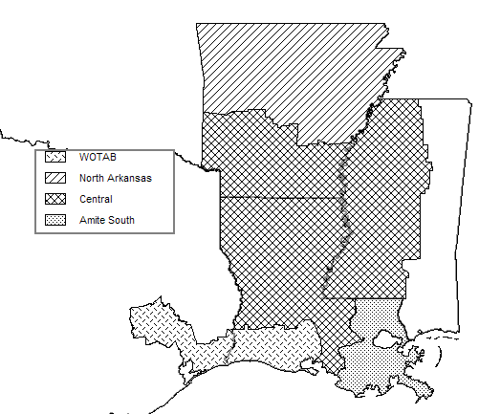

In this 2006 Long-Term RFP preference will given to resources located in the Amite South and WOTAB planning regions. Factors influencing this preference include:
- The System seeks to achieve a geographic dispersion of resources with generation located proximate to load.
- The SSRP anticipates the addition of long-term CCGT resources in each planning region to address load following needs.
- Recent additions of capacity have been in the Central region.
- Existing Solid Fuel resources are located primarily in the northern part of the System.
Although regional location will be a consideration, regional location will not exclude any proposal from consideration. The primary factor in the selection of resources will be the relative economic benefits provided by each proposal.
The TAG also will evaluate the proposals to determine whether any proposed resources may have potential transmission benefits that should be considered by EET in the Stage 1 analysis to determine the appropriate Candidate Proposal list. The potential transmission benefits that will be estimated include savings derived from:

- Relieving a reliability must run constraint by providing a lower cost generation alternative (described in Section 1.4.1 of the RFP);
- Providing counterflow on constrained transmission elements that may allow more economic power to be transferred into the region; or
- Delaying approved transmission projects posted by TBU on the Entergy OASIS Website by a date certain.

Note that the models and input files that will be posted on the RFP Website will not provide Bidders with the ability to replicate these analyses, because they will require the use of confidential operating data for the Entergy System’s existing resources.

The information developed by the TAG in this initial transmission analysis will be provided to the EET for its use in developing the Candidate Proposal list. This initial transmission analysis will not be used to eliminate any proposal from further consideration. Rather, it will provide information to the EET in the Stage 1 analysis for their consideration in determining whether any other proposals should be deemed Candidate Proposals, a designation that is necessary in order for a proposal ultimately to be considered for inclusion on the Preliminary Shortlists.

2.2. Detailed Transmission Analysis

In the detailed transmission analysis, the TAG will identify potential alternatives to alleviate constraints that may prohibit the Bidder’s resource from qualifying as a Long-Term Network Resource as identified in the initial transmission evaluation. From this analysis, Delivery Cost Adders will be estimated for each proposal under consideration. The Delivery Cost Adder is not paid by the Bidder; rather, it is added to the respective proposal’s total production cost by the EET during development of the Candidate Proposal list.

One or more Delivery Cost Adders may apply if the TAG can identify alternatives to alleviate the identified constraints on a long-term and short-term basis through prioritization and management of existing transmission capability usage. The mitigation alternatives that the TAG will assess include the following long-term options:

- Transmission upgrades;
- Delisting of existing Network Resources; (short-term and long-term)

These studies will be performed by the TAG prior to submission of the SIS requests to TBU. The TAG also will evaluate the following short-term mitigation alternatives:

- Counter-flow generation portfolio selection ; and (short-term only)
- Active transmission service management. (short-term only)

Counter-flow and active transmission service management, will be utilized only on a short-term basis as a bridge until the required transmission upgrades are available to provide a long-term solution.

Bidders will have access to the same information that TAG will utilize (1) to identify whether potential constraints exist that may prohibit the Bidder’s resource from qualifying as a Long-Term Network Resource; (2) to estimate the upgrade cost required to alleviate those constraints on a long-term basis; and (3) to identify other potential constraint mitigation alternatives. Bidders may provide in the RFP Proposal Submission Form only their best recommendation to alleviate potential constraints. The TAG will consider the estimated cost and the validity of any Bidder identified required upgrades and/or constraint mitigation. The constraint mitigation recommendations included in the RFP Proposal Submission Form must meet all transmission reliability criteria without degrading the reliability of the overall System.

From this analysis, the TAG will develop Delivery Cost Adders for each viable mitigation alternative. The lowest cost mitigation alternative or combination of mitigation alternatives that allow a proposal to qualify as a Long-Term Network Resource for the Delivery Term will be added to the respective proposal’s total production cost by the EET during development of the Candidate Proposal list. Furthermore, the EET will consider whether any additional proposals should be considered for the Candidate Proposal list based upon the results of this analysis. The identified mitigation alternatives may or may not be implemented; however, application of the corresponding Delivery Cost Adder to constrained proposals is intended to render each of the Candidate Proposals comparable with respect to transmission deliverability. The following sections describe each of the mitigation alternatives and the development of the associated Delivery Cost Adders.

2.2.1 Potential Transmission Upgrade Mitigation Alternative

The TAG will develop a transmission upgrade alternative to alleviate the constraints for a particular proposal. The parameters of the proposed transmission upgrade(s) will be modeled using transmission element parameters that resemble an existing line or transformer with similar characteristics. The cost of such topology modifications will be derived using a transmission upgrade calculator (which will be available on the RFP Website) to produce a Delivery Cost Adder. The costs are based on publicly available information provided on the Entergy OASIS website, such as Transmission Summit Data and System Impact Studies. To be considered viable, any potential upgrades will have to meet the thermal and voltage study criteria previously mentioned for both the 2009 and 2014 load flow models.

2.2.2 Delisting Mitigation Alternative

For constrained proposals satisfying the threshold criteria conditions listed below, an analysis will be conducted to determine whether the identified constraints potentially could be mitigated by delisting/displacing some of the Entergy System’s existing oil/gas Network Resources (no nuclear, coal, or hydro fueled resources will be included in this evaluation), to the extent they are expected to be less economic to customers than the proposal resource. A matrix of response factors will be developed for each delisting/displacement candidate and each Candidate Proposal relative to specific transmission constraints identified for that proposal. Only constrained proposals that satisfy the following threshold criteria for all constraints will be analyzed for further delisting/displacement consideration:

1) the total amount of generation from the Entergy System’s Network Resource(s) to be considered for delisting/displacement multiplied by the its response factor(s) on the constrained transmission element must be greater than or equal to the total amount of the proposed generation multiplied by the proposal’s response factor on the constrained transmission element;
2) the total amount of generation required from a Network Resource must be less than or equal to the total amount of generation available from the Network Resource; and
3) the total amount of generation required from a Network Resource must be less than or equal to 1.25 times the proposal.

If the threshold conditions are met, then TAG will develop a Delivery Cost Adder under this method. The Entergy System generating capacity considered available for possible delisting or displacement for each proposed resource will be limited to a maximum of two plants per proposed resource and will be determined on a regional and System-wide basis considering a variety of operational and area planning factors.

Delisted/displaced capacity is expected to remain available to the System Operator, and may still be available for dispatch many hours of the year through the use of short-term Network Resource status or non-firm transmission service granted based upon the then current conditions.

The Delivery Cost Adder for the delisting/displacement mitigation alternative will be determined on a case-by-case basis considering, but not limited to, the specific unit or units delisted/displaced, the estimated amount of time the delisted/displaced unit or units are expected to be unavailable to the System Operator, the location of the delisted/displaced unit or units, and the expected availability of replacement resources.

2.2.3 Counter-flow Generation Portfolio Analysis Mitigation Alternative

For constrained proposals satisfying the threshold criteria conditions listed below, an analysis will be conducted to determine whether the identified constraints could potentially be mitigated by counter-flow produced by existing Entergy System generation resources. An assessment of the potential for mitigating transmission delivery issues created by a proposal through submitting transmission service requests for resources that create “counter-flows” on the constrained transmission facilities will be performed if the proposal satisfies the following threshold criteria:

1) the total amount of available counter-flow resources from the Entergy System’s Network Resource(s) multiplied by the its response factor(s) on the constrained transmission element must be greater than or equal to the total amount of the proposed generation multiplied by the proposal’s response factor on the transmission constrained element; and
2) the total amount of generation required from a counter-flow resource must be less than or equal to 1.5 times the proposal.

If the threshold conditions are met, then TAG will develop a Delivery Cost Adder under this method. The potential counter-flow resources and their respective response factors to System constraints will be developed using existing Entergy System Network Resources. The expected dispatch availability, i.e., capacity type of all counter-flow resources, must be expected to overlap all dispatch periods during which the proposal resource would be constrained.

Counter-flow resources for each proposed generating resource will be limited to a maximum of two plants and must completely alleviate potential transmission constraints to facilitate obtaining transmission service.

The Delivery Cost Adder for the counter-flow portfolio mitigation alternative will be based upon the energy cost difference between the mitigating Entergy System’s Network Resource(s) and the proposal multiplied by the amount of time the counter-flow is needed.

2.2.4 Active Transmission Service Management Mitigation Alternative

For resources that will begin delivery prior to the completion of necessary upgrades, a series of short-term transmission service requests for short-term Network Resource status may be required to operate the facility until the long-term mitigation strategy is implemented. The following criterion will be used to evaluate the resource:

the savings provided by the proposal prior to the completion of necessary upgrades will be adjusted to reflect cost of replacement capacity for the period for which transmission service is not available until the transmission upgrades are placed in service.

For the purpose of this evaluation, the Delivery Cost Adder will be based upon the reduction in System production cost benefits associated with reduced proposal resource availability. The EET will determine whether it is feasible to obtain the capacity that will be needed, on an interim basis, to provide the capacity that cannot be provided by the long-term resource during the period of time in which transmission service is anticipated to be unavailable, including the cost of that capacity. The availability and price of such interim capacity is necessary to ensure that the long-term resource may be considered to be used and useful in the public service during the interim period when the long-term transmission upgrades are being completed.

2.3. Submission of SIS requests to TBU

After the detailed transmission evaluation has been performed on the Candidate Proposals to determine the appropriate mitigation strategies for the constrained resources, the Candidate Proposals will be finalized and submitted to the TBU through the Entergy OASIS website to request an SIS. Upon submitting the SIS request for each Candidate Proposal, the TAG will provide to TBU a letter that describes the proposed mitigation alternatives to be studied by TBU when determining if the resource will qualify as a Long-Term Network Resource. The SIS provided by the TBU will estimate the cost of any upgrade associated with qualifying a proposal a Long-Term Network Resource and determine if any viable delisting options exist for the proposed resources.

The comprehensive evaluation of all proposals submitted in response to this RFP, as well as consideration of potentially desirable delisting options, may require a large number of service requests to be submitted to TBU. There is a possibility that the TBU process may not be able to accommodate a large number of transmission service requests or a large number of requests for studies within the time frames set forth in TBU’s process; thus, the TBU may not be able to complete the SIS studies within the expected 90 day window.

In addition, the queue-based SIS process potentially would not be practical for evaluation of all proposed resources particularly because 1) the TBU’s analytic process must assume some order of sequence of requests in order to examine the incremental impacts of any proposed resource on the transmission system, and 2) the results of the proposals need to be received simultaneously. Therefore, the TAG will submit sequentially through the Entergy OASIS website the SIS requests, as well as any delisting options, for the Candidate Proposals. Those requests will be followed by a letter instructing TBU to consider them on a batched basis. TBU will be instructed to study each proposed resource individually, rather than stacking the proposed resources for analysis which is the standard procedure in the queue-based process. The TAG also will request that TBU issue the results of these batched requests at one time, rather than as the studies for proposed resources and delisting options are completed.

Bidders are strongly encouraged not to submit their own SIS requests to TBU for the proposed resources which could result in significant delays in receiving the batch study results. The TAG will be responsible for submitting the SIS request for each Candidate Proposal to TBU.

Note also that Bidders are not allowed to submit requests for qualification as Network Resources through the Entergy OASIS website. Under the OATT, only network customers can submit such requests.

If the results are received within time to be considered by the EET (expected to be within 90 days from initial submission on the Entergy OASIS Website), then Delivery Cost Adders for the Candidate Proposal will be adjusted to reflect the SIS study results. If the results are not received from TBU in a timely fashion, Delivery Cost Adders developed through the detailed transmission evaluation described in Section 2.1.3 will be used by the EET.

CHART A

CHART B
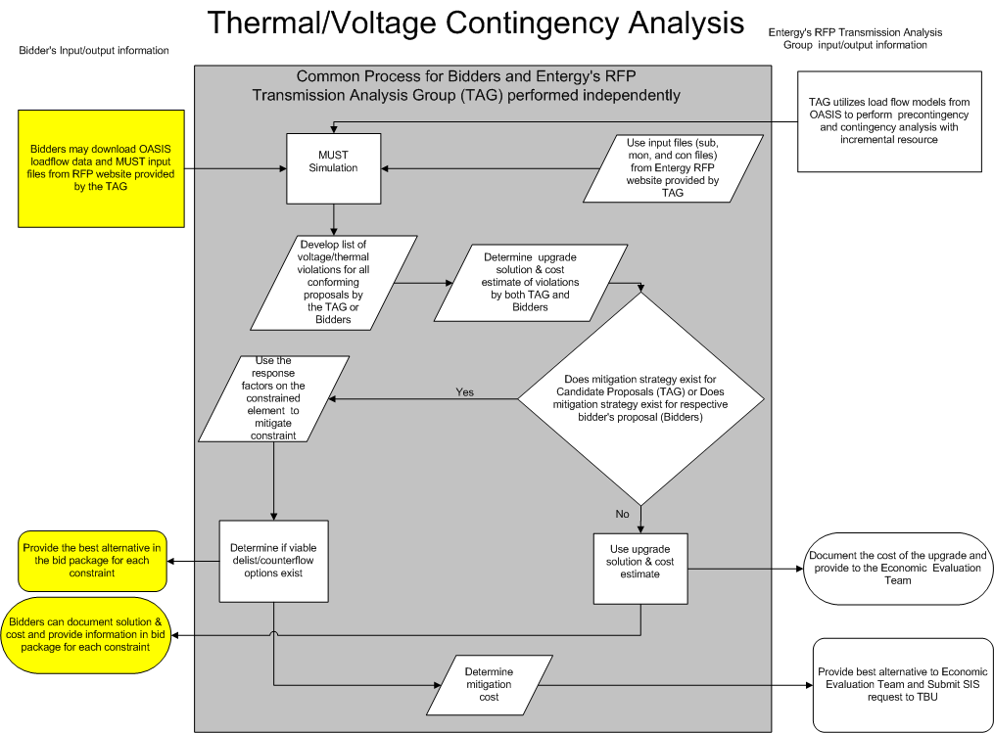

ICT Proposal means the proposed revisions to Entergy’s Open Access Transmission Tariff that are the subject of FERC Docket No. ER05-1065-000
A response factor is a calculation of the percentage of a resource’s power output that flows through a constrained transmission element due to the resource’s location and the System’s transmission network topology.

